**Project Design Phase-II**

**Data Flow Diagram & User Stories**

|  |  |
| --- | --- |
| Date | 22 June 2025 |
| Team ID | LTVIP2025TMID35377 |
| Project Name | Smart Sorting: Identifying Rotten Fruits and Vegetables Using Transfer Learning |
| Maximum Marks | 4 Marks |

**Data Flow Diagrams:**

A Data Flow Diagram (DFD) is a traditional visual representation of the information flows within a system. A neat and clear DFD can depict the right amount of the system requirement graphically. It shows how data enters and leaves the system, what changes the information, and where data is stored.

**Example: DFD Level 0 for smart sorting**

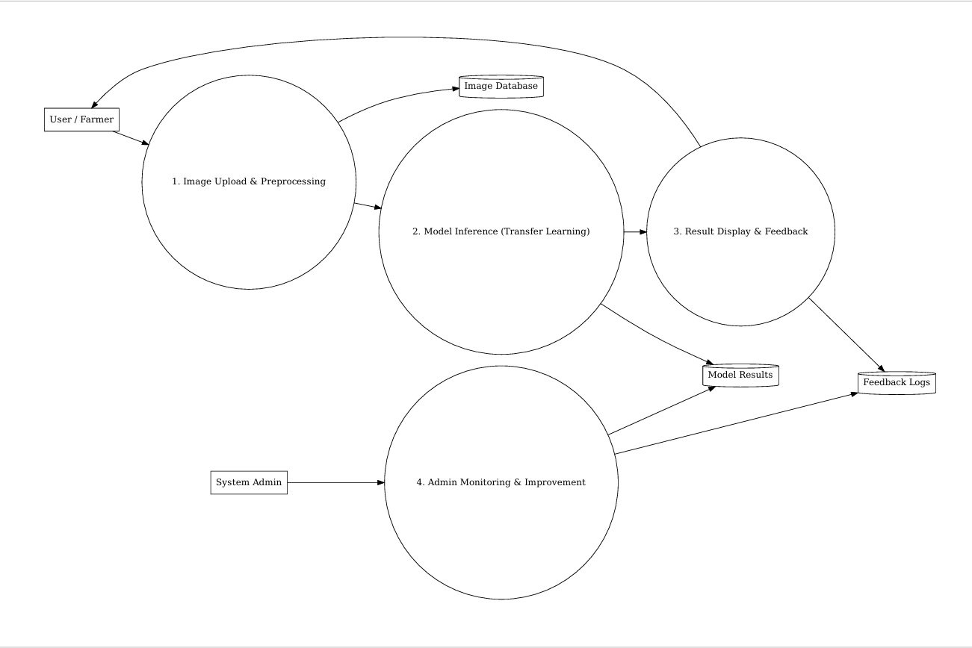

**User Stories:**

| **User Type** | **Functional Requirement (Epic)** | **User Story Number** | **User Story / Task** | **Acceptance Criteria** | **Priority** | **Release** |
| --- | --- | --- | --- | --- | --- | --- |
| **Farmer / Vendor** | **Registration** | **SS-US-1** | **As a user, I can register with my email and password to access the smart sorting system.** | **I can log in to the system after registering with valid credentials.** | **High** | **Sprint-1** |
| **Farmer / Vendor** | **Registration** | **SS-US-2** | **As a user, I receive a confirmation email after successful registration.** | **I receive an email with a confirmation link and can verify my account.** | **High** | **Sprint-1** |
| **Farmer / Vendor** | **Login** | **SS-US-3** | **As a user, I can log in with my registered email and password.** | **I can successfully log in and access the dashboard.** | **High** | **Sprint-1** |
| **Farmer / Vendor** | **Image Upload** | **SS-US-4** | **As a user, I can upload or capture images of fruits/vegetables for sorting.** | **The system accepts image input and confirms receipt.** | **High** | **Sprint-2** |
| **Farmer / Vendor** | **Prediction** | **SS-US-5** | **As a user, I can see whether the uploaded produce is “Fresh” or “Spoiled” based on AI detection.** | **The prediction is shown with a label and confidence score.** | **High** | **Sprint-2** |
| **Farmer / Vendor** | **Feedback** | **SS-US-6** | **As a user, I can give feedback if the prediction seems incorrect.** | **A form or button allows me to report incorrect prediction.** | **Medium** | **Sprint-3** |
| **Farmer / Vendor** | **View History** | **SS-US-7** | **As a user, I can view the history of my uploaded images and predictions.** | **I can see past records with timestamps and outcomes.** | **Medium** | **Sprint-3** |
| **Admin** | **Manage Users** | **SS-US-8** | **As an admin, I can view, edit, or delete registered users.** | **Admin panel displays user list with action buttons.** | **Medium** | **Sprint-2** |
| **Admin** | **Monitor Predictions** | **SS-US-9** | **As an admin, I can monitor AI prediction logs to ensure the system is performing accurately.** | **Admin sees dashboard with prediction counts, accuracy trends.** | **Medium** | **Sprint-3** |
| **Admin** | **Model Feedback Loop** | **SS-US-10** | **As an admin, I can review user feedback and retrain the model with new data.** | **Admin has access to feedback repository and retraining workflow.** | **High** | **Sprint-4** |
| **System** | **Transfer Learning Inference** | **SS-US-11** | **As a system, I apply a trained model to infer the condition of fruits/vegetables from uploaded images.** | **Model processes the input and returns result within acceptable time and accuracy.** | **High** | **Sprint-2** |